STAND DEVELOPMENT MONITORING DAMAGE CRITERIA

FOR EVEN-AGED (AGE CLASS 2 & 3) CONIFEROUS TREES
(Revision 6: 12 February, 2010)

INTRODUCTION

The FREP Stand Development Monitoring (SDM) protocol has been developed to assess stand performance, from a timber yield perspective, 10-30 years following free-growing declaration. The data gathered will help determine whether these stands are on a trajectory that will result in a productive mature stand. The results of a SDM assessment can be used as an evidentiary base to support Forest Practices and Planning Regulation section 97(6) which states “a free growing stand must also meet the requirements, 20 years after the commencement date or 5 years after the completion of the last of any brushing or spacing treatments, and that it will more likely than not be free of forest health concerns or vegetative competition that could result in its growth being impeded.”

SDM damage criteria are based on the free-growing damage criteria, but they have been tailored for determining the health status of stands at a later stage of development (i.e., even aged, age class 2 & 3). These damage criteria are designed to determine the damage to, and acceptability of, individual conifers across the province. These criteria do not apply to broadleaf species. SDM damage criteria, in general, are more lenient than free-growing damage criteria as there is more confidence in a tree’s continued survival than there is at age 10-15 when stands are declared free-growing. The SDM damage criteria are based on the most current knowledge of forest-damaging agents, and are provided to help users exercise their professional judgment in identifying the "healthy" part of “healthy, well-spaced trees”.

The table below lists various types of damage, causal agents and species of trees. Agents and damage are often referred to by their codes listed on the Ministry of Forests Integrated Data Dictionary Pest_Species_Code list (partly listed on the Silviculture Damage Agent and Condition Codes (FS 747) field form). Tree species abbreviations are listed in the Forest Productivity Council publication Minimum Standards for the Establishment and Remeasurement of Permanent Sample Plots in British Columbia (1999).

These criteria have been developed with a consideration to both future merchantability and survivorship in mind. These criteria are expected to be revised as SDM matures and as we learn more about the health and productivity of managed stands post free-growing. At the same time, climate change will increase host stress in many areas making trees more susceptible to pests and pathogens. Forest health agents previously considered benign may increase in incidence and severity, warranting their inclusion in these damage criteria.

SDM DAMAGE CRITERIA FOR EVEN-AGED (AGE CLASS 2 & 3) CONIFEROUS TREES (Revision 6).

PLEASE READ the preceding introduction before using the following table and figures.
LOCATION  OF DAMAGE | TYPE OF  DAMAGE | TREE BEING ASSESSED IS  UNACCEPTABLE IF: | HOST  SPECIES | LIKELY DAMAGE  AGENTS & DAMAGE AGENT CODES | COMMENTS
STEM | Wound  (including sunscald and girdling) | - the tree has a girdling wound which is greater than 33% of the stem circumference, or  - the tree has a wound which is equal to or greater than 1m in length. | All | Biotic causes:  bear AB, cattle AC, hare AH, moose AM, porcupine AP, squirrel AS, beaver AZ, atropellis canker DSA  Abiotic causes:  sunscald NZ, logging TL, mechanical TM,fire NB, windthrow NW | A wound is defined as an injury in which the cambium is dead (e.g., sunscald) or completely removed from the tree exposing the sapwood. Measure the wound across the widest point of the exposed sapwood (or dead cambium when the tree is damaged by sunscald).  Healed over wounds (=scars) are acceptable.
STEM | Insect mining at root collar | - the tree is currently attacked by a bark-mining insect such as a weevil or a beetle and exhibits symptoms such as foliage discoloration, thinning and/or reduced height growth increments | Pl, Sx | root collar weevil IWW, red turpentine beetle, IBT, lodgepole pine beetle IBL | Only trees that are symptomatic should be checked for insect infestation or mining damage. Non-symptomatic trees are presumed to be unaffected by insect mining.
STEM | Deformation (including crook, fork, browse, and dead or broken top) | - the pith is horizontally displaced more than 30 cm from the point of defect and originates above 30 cm from the point of germination, or | All | Biotic causes:  Bear AB, cattle AC, deer AD, elk AE, moose AM, defoliators ID, spruce leader weevil IWS, lodgepole pine terminal weevil IWP, sequoia pitch moth ISQ, Abiotic causes:  frost NG, hail NH, snow NY, drought ND, logging TL, mechanical TM, Deep planting TP | For horizontal displacement see Figure 1.
 |  | - the tree has a fork in the lower 2/3 of the stem and the smaller of the stems is >¼ the diameter of the main stem, or | All |  | For forking, see Figure 2.
 |  | - the tree has a dead or broken top at a point that is >5 cm in diameter. | All
STEM | Lean and sweep | - the tree leans >30° from the vertical with or without growth correction (sweep) | All | flooding NF, snow NY, slides NS, wind NW, mechanical TM
STEM | Suppressed | - the tree has a height to diameter ratio > 100  - or, tree has < 20% Live Crown | Pl, Py, Pw, Fd, Sx, Lw | Suppressed light environment, leading to high potential for competition induced mortality VT | Note: Only trees that are clearly not expected to reach rotation should be deemed unacceptable
STEM | Infection  (including cankers and galls) | - any infection occurs on the stem, except DSG  - DSG stem gall affects >25% of stem circumference | All  Pl, Py | comandra blister rust DSC,  stalactiform blister rust DSS  white pine blister rust DSB,  western gall rust DSG, | Note: Wounds caused by rodent feeding around rust cankers should have stem rust recorded as the causal agent.

LOCATION  OF DAMAGE | TYPE OF  DAMAGE | TREE BEING ASSESSED IS  UNACCEPTABLE IF: | HOST  SPECIES | LIKELY DAMAGE  AGENTS & DAMAGE AGENT CODES | COMMENTS
STEM | Bark mining | - Any of the following signs are visible: pitch tubes, boring dust, exit holes on bark surface, galleries under the bark | Pl, Sx, Fd | Douglas-fir beetle IBD, mountain pine beetle IBM, spruce bark beetle IBS, Ips pini IBI, Pityogenes & Pityophthorus IBP | Note: pitch tubes can be associated with trees that have successfully repelled bark beetles, bark must be removed above pitch tube to confirm successful attack (successful galleries will be filled with frass and not pitch, contain adult beetles and/or larval galleries).  Stressed trees are susceptible to secondary bark and twig beetles.
BRANCH | Infection  (cankers) | - an infection occurs on a live branch less than 20 cm from the stem. | Pw, Pl, Py | white pine blister rust DSB,  comandra blister rust DSC,  stalactiform blister rust DSS
BRANCH | Gouting | - any adelgid gouting occurs on a branch. | Ba, Bg, Bl | balsam woolly adelgid IAB. | Gouting is defined as excessive swelling of a branch or shoot caused by balsam woolly adelgid, and is often accompanied by misshapen needles and buds. It is most common on branch tips and at nodes near the ends of branches. Consult a recent distribution map to identify the geographic extent of this pest.
FOLIAGE | Dothistroma | - > 50% of tree foliage has been removed by Dothistroma in ICH, CWH, and SBS biogeoclimatic zones. | All P | Dothistroma needle blight, DFS | See Figure 3
FOLIAGE | Douglas-fir tussock moth and hemlock looper | - >60% of tree foliage has been removed due to hemlock looper of Douglas-fir tussock moth. | Fd, Hw | Douglas-fir tussock moth (IDT), hemlock looper (IDL)
FOLIAGE | Other defoliating insects and disease | - >80% of tree foliage has been removed due to foliage disease. | All other conifers Note: Lw | foliage diseases DF, defoliating insects ID | Note: Lw is a deciduous tree so defoliation has less impact, Repeated defoliation attacks will result in dead branches, apply the >80% rule to obviously dead branches, not just defoliated branches as with other conifer species  See Figure 3
FOLIAGE | Elytroderma needle cast systemic infection | - The top 2/3’s of the tree is affected and the growth is clearly stunted. | Pl, Py | Elytroderma needle cast DFE | Note: To confirm infection the surveyor must observe signs of the pathogen as small dark streaks on dead foliage
STEM  OR BRANCH | Dwarf mistletoe infection | - Any layer 1 and 2 tree with a Hawksworth rating >3 (Figure 4).  - any infection occurs on the stem or a live branch of layer 3 trees.  - a susceptible tree is located within 10 m of an overtopping tree, which is infected with dwarf mistletoe. | Hw, Pl, Lw, Fd | Douglas-fir dwarf mistletoe DMF,hemlock dwarf mistletoe DMH, larch dwarf mistletoe DML, lodgepole pine dwarf mistletoe DMP, | Note: To confirm infection, the surveyor must observe mistletoe aerial shoots or basal cups on regeneration or on live or dead fallen brooms.  Overtopping tree is a tree that is in an overtopping layer.

LOCATION  OF DAMAGE | TYPE OF  DAMAGE | TREE BEING ASSESSED IS  UNACCEPTABLE IF: | HOST  SPECIES | LIKELY DAMAGE  AGENTS & DAMAGE AGENT CODES | COMMENTS
ROOTS | Root disease | - sign(s) or a definitive combination of symptoms of root disease are observed. | All | armillaria root disease DRA, blackstain root disease DRB laminated root rot DRL, annosus root disease DRN tomentosus root rot DRT, | Signs are direct evidence of the pathogenic fungus including fruiting bodies, distinctive mycelium or rhizomorphs. Symptoms include foliar chlorosis or thinning, pronounced resin flow near the root collar, reduced recent leader growth, a distress cone crop, and wood decay or stain. An individual symptom is not sufficient to identify a root disease.
 |  | - infected tree found in plot. See comments for well-spaced tree net down calculation. The multiplier for all root disease infected trees is 1. | All  Fd, Bg,Hw,Sx, Se, Lw  Fd, Pl, Pw, Sx  Se, Sx, Fd, Pl  Ba, Hw, Ss, Fd | armillaria root disease DRA,  laminated root rot DRL.  black stain root disease DRB.  tomentosus root rot DRT.  annosus root rot DRN | Note: All conifer species are considered susceptible. All broadleaf species are considered not susceptible for survey purposes only.  Note: Cw, Pl, Pw, Py, and all broadleaf species are considered not susceptible for survey purposes only.  Note: All other conifers and broadleaf species are considered not susceptible for survey purposes only  Note: Bg, Bl, Cw, Cy, Pw, Py, and all broadleaf species are considered not susceptible for survey purposes only.  Note: Cw, Cy, Pw, Pl, Py, and all broadleaf species are considered not susceptible for survey purposes only.  Example: How to apply net down for all root diseases.  If root disease-infected trees are found in the plot:  - In the first sweep, determine the total number of healthy, well-spaced trees using the prescribed minimum inter-tree distance (MITD) (e.g., 12 trees);  - In a second independent sweep, determine the number of well-spaced infected trees using MITD (e.g., 1 infected tree);  - From the number of susceptible healthy well-spaced trees found in step 1, subtract the number of well spaced infected trees. The result (e.g., 11 trees) is the adjusted number of healthy, well-spaced trees tallied for the plot.  .
 |  |  |  | .
 |  |  |  | . | .

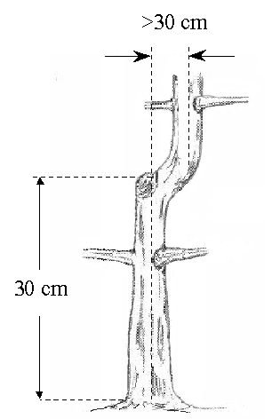
Figure 1. Determining horizontal displacement when assessing stem deformation. This is only done when the tree has five seasons' growth after damage occurs.

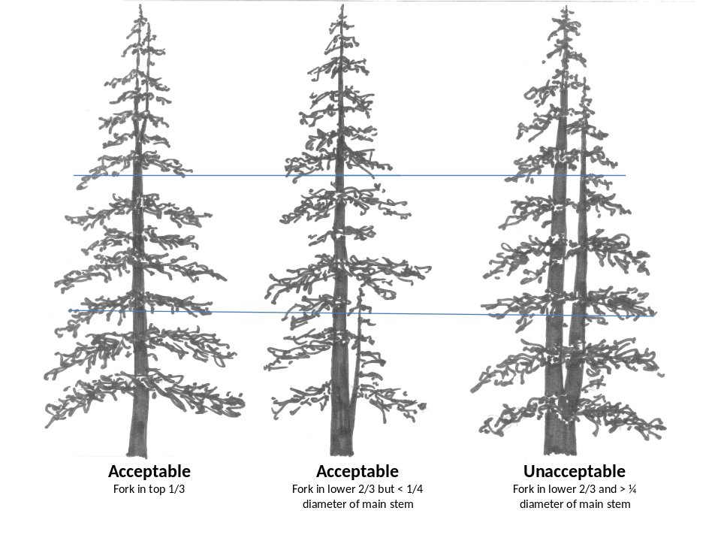
Figure 2. Acceptable and unacceptable forking in age class 2 & 3 conifers.

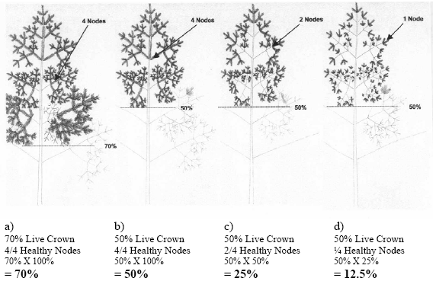
Figure 3. Calculating defoliation for Dothistroma-afflicted conifers.

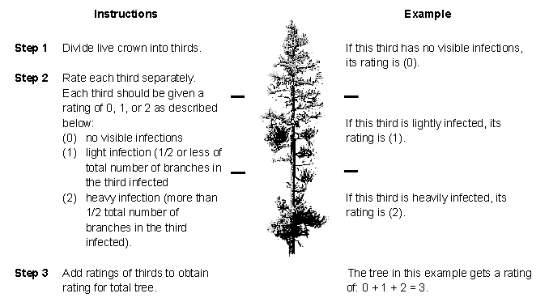
Figure 4. The Hawksworth six-class dwarf mistletoe rating system.

Definitions

basal resinosis (pitching): copious exudation of pitch at the base of the stem at or below the root collar. This symptom often is associated with armillaria root disease or attack by Warren’s root collar weevil.

decay: the disintegration of plant tissue. The process by which sound wood is decomposed by the action of wood-destroying fungi and other microorganisms.

fork: two or more leaders have originated from the loss of a leader or apical shoot. At free-growing age, a fork is considered persistent if it has not differentiated in height between competing leaders by more than 5 cm after five years of growth since the leader damage occurred. Forks may provide entry points for decay fungi, are points of weakness during felling, and may create waste in the highest value first log.

gall: nodule or lump of malformed bark or woody material caused by a variety of damaging agents, such as western gall rust and some insects.

gouting: excessive swelling of a branch or shoot, often accompanied by misshapen needles and buds. Most common at nodes on branches and frequently caused by balsam woolly adelgid on true firs (Abies spp).

Height to diameter ratio: height in meters divided by dbh in meters.

infection: characterized by a lesion or canker on stem or branches or by swelling around the entrance point of a pathogen.

injury: damage to a tree by a biological, physical or chemical agent.

scar: a wound completely healed-over by callus tissue

wound: an injury where cambium is dead (e.g., sunscald) or completely removed. Wounds often serve as entry points for decay fungi

